SR# _____ Name: ___________________ Date:___________
Gateway Middle School Planner Checklist

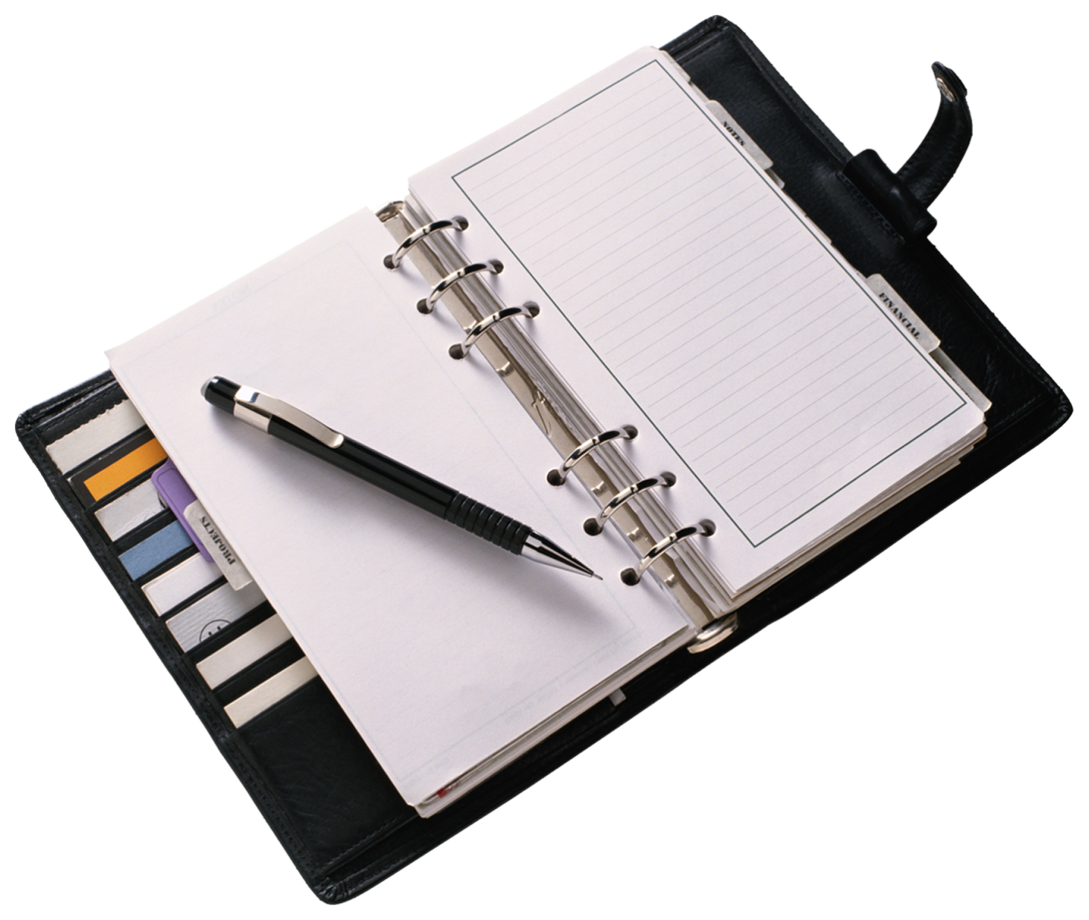  In my planner I: | Got it! | Working on it!
- put a box ☐ in each class section.
- write “none” when I have no homework in a class.
- write my homework assignment correctly.
- write my homework assignment legibly.
- write an “X” in the box ☒ when I have completed the assignment.
- highlight any missing homework to remind myself to complete it.
Comments:

SR# _____ Name: ___________________ Date:___________
Gateway Middle School Planner Checklist

In my planner I: | Got it! | Working on it!
- put a box ☐ in each class section.
- write “none” when I have no homework in a class.
- write my homework assignment correctly.
- write my homework assignment legibly.
- write an “X” in the box ☒ when I have completed the assignment.
- highlight any missing homework to remind myself to complete it.
Comments:

